After determining the requirements of the system we will describe it’s major components , their relationship ,and how they interact with earth other.

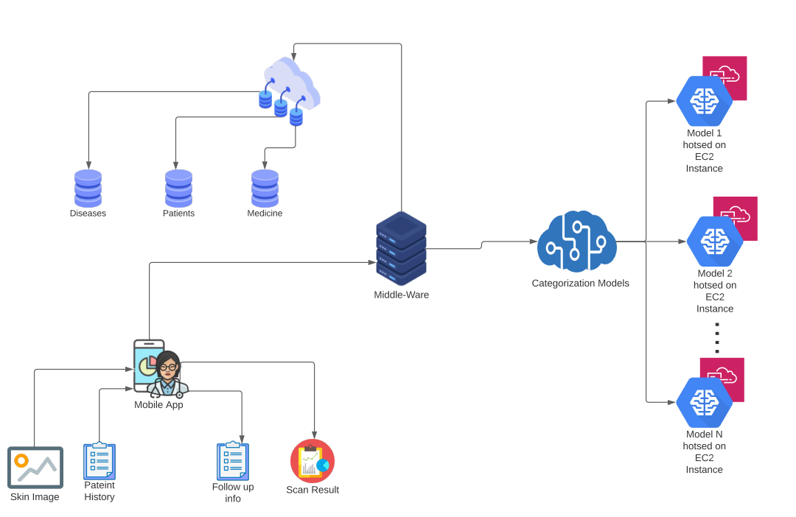

* User write about his medical history (if he didn’t sign in before ) and answer some questions about his situation and take image for disease or (upload from gallery) then app will replay with the prediction of disease and some information about it .
* Doctors will write information and medicines for diseases on the website and they will insert in database.
* Middle-ware backend will process information from doctors and users beside information about users and doctors and it will be responsible of :
  + Communicate with categorization models API to categorise disease from images and choice between them.
  + Process answers of with storaged answers and information.
  + Reply disease and information about it to user.
* Categorization models API : microservice communicate with middle-ware to respond predictions of diseases.